Favorites Sum and difference: double and half: sum and product: odd identities
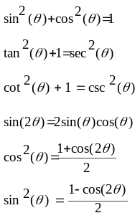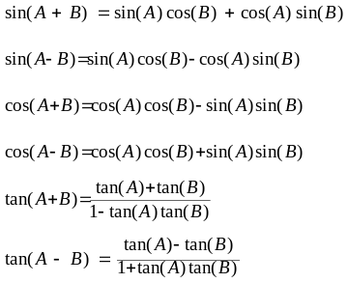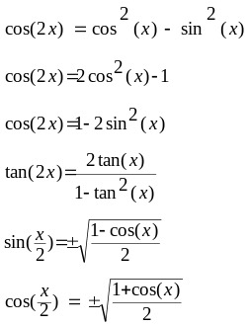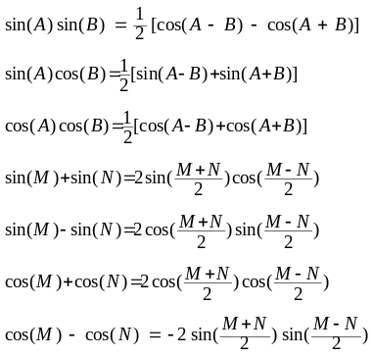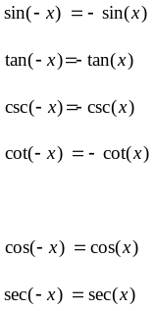
Event identities
A = amount of money after t years
P = initial amount
r = rate as decimal
n = number of times interest is compounded per year
t = time measured in years

The domain of the restricted sine function is 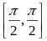and the range is. The domain of the arcsin function is and the range is. The domain of the restricted cosine function is and the range is. The domain of the arccosine function is and the range is. The domain of the restricted tangent is 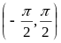and the range is. The domain of the arctangent function is and the range is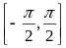.
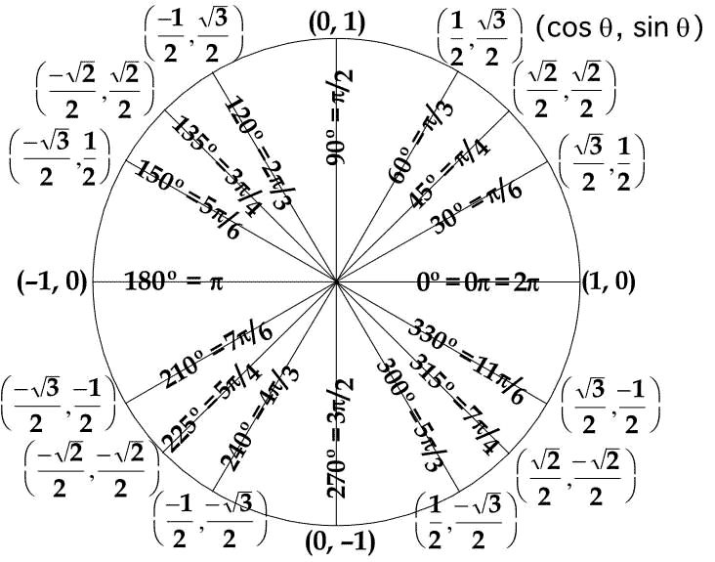
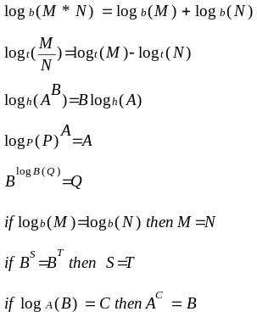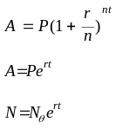
Horizontal asymptote: if N>D no horizontal asymptote; if N=D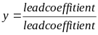; if N<D y=0
Vertical Asymptote: x= factor denominator; x-intercepts: x= factor numerator; y-intercept: y=x when x=0
Asymptote intercepts: set y to horizontal asymptote and solve for x
Cannot take log of 0 or negative
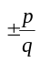 Where p divides the constant term in the polynomial and q divides the lead coefficient of the polynomial

Symmetry: y-axis - if f(x) =f(-x) - even; origin – if f(x) =-f(x) – odd; y = x if g(f(x)) & f(g(x)) = x neither;

Domain x – set of letters, co-domain – all mailboxes, range y – boxes that actually receive mail, one-to-one – each box gets no more then 1 letter, onto – at least 1, one-to-one and onto – exactly 1

Domain – x; Range – y; co-domain – all possible y-values;
x>a open circle; x >= closed circle
Even – all signs stay the same; odd – all change; neither – don’t all stay the same, don’t all change

Systems: infinitely many – same line, no solution – parallel lines; one solution – lines intersect

Shifting inside parenthesis x-axis; outside parentheses y-axis; skinny if A>1; fat is A<1

